**Problem Q-28[Multi-period production]**

A company named KIDS WORLD is a toy manufacturing company and sells toys for the kids. They found a new retailer and the demand for that retailer for next 4 months is as follow. A retailer wants to buy 720,800,1000 and 750 units of variety of games like board games, puzzle games for the age group of 5-12. In order to meet the demand of the retailer, the production costs per unit per month are $70, $85, $50 and $80. The holding cost (storage cost) per unit at the end of each month is $25. If there are any products which are left at the end of 4 months, can be sold for $66. Assuming there is no inventory at the beginning and also the retailers demand has to be met on time, develop a mathematical model to minimize the net cost incurred in meeting the demand for next four months.

**Discussion: -**

The objective of this problem is to design a multi-period production plan for KIDS WORLD to minimize its production cost while meeting the demand of the retailer on time.

**Note: -** The Company do not have the inventory beforehand and also no backlogging is allowed. Also, it can sell the remaining products at the end of the 4th month for $60.

**Input Variables: -** Demand of the retailer, production cost per unit for each month, storage cost per unit at the end of each month.

**Mathematical Model:**

**Parameters:**

$D_{i}$ = Demand of the products in month i (i ∈ 1,2,3,4)

$C_{i}$ = Production cost per unit in month i (i ∈ 1,2,3,4)

S = Storage cost per unit

P = Selling price per unit at the end of the 4th month

$I_{0}$ = Inventory for month 1. $I_{0}=0$

**Decision variables:**

$X_{i}$ = Number of units to produce for month i (i ∈ 1,2,3,4)

**Objective:**

Minimize total cost

${Min}_{Xi}$ [ $\sum_{i=1}^{4}{\left(X_{i}*C_{i}\right)+(I_{i}*S)}$] – [$I_{4}*P$]

**Constraints:**

$X_{i}≥0$ (Non-negative constraint)

$X_{i}+ I_{i-1}≥ D_{i}$ (Demand Constraint)

${{I_{i}= I}_{i-1}+ X}_{i}- D_{i}$ (Inventory balancing)

**Excel Model Results:**

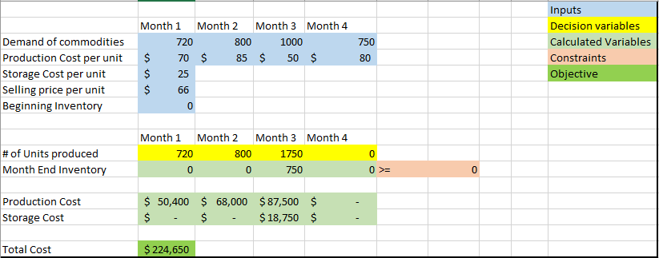

**Sensitivity Report:**

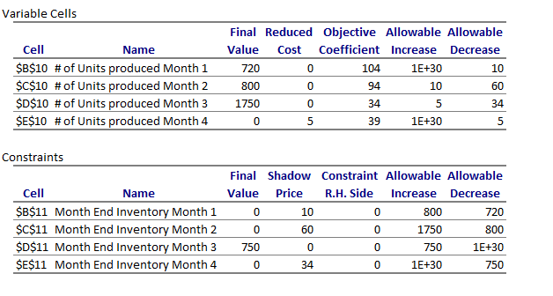

By looking at the sensitivity report, we can say that the company can produce maximum 720, 800, 1750 respectively for the first 3 months.

By looking at the report we can see that the solver is producing the month 4 production in the month 3 itself.

Also, if you increase a unit in month 1 the shadow product for that month is 10 but it is significant only for maximum 800 unit increase, and 720 unit decrease. But if this exceeds 800 than the shadow price for that will change. You need to re-run the solver to find other shadow price.

But we can also see that there is no shadow price associated with the month 3 but for that you can only increase 750 units, however you can decrease as many units as you want.